The Association of Kent Veteran Golfers

The Player of the Year competition
The Player of the Year Shield was introduced in 2017 in order to reward consistent performance and encourage frequent participation.
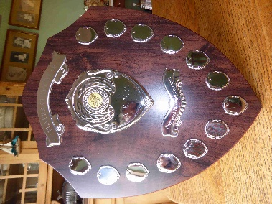
The shield is insured by AKVG. The winner must have it engraved and is entitled to keep it for 10 months.
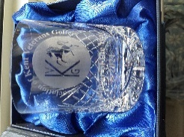
The winner also receives an engraved, crystal spirit tumbler as a memento.

This is how the competition works:
Our six singles Stableford competitions are the Qualifying events for this competition – they are denoted by a ‘Q’ on the fixture list.
So that the winner can be presented with the trophy at the final fixture each year we carry forward the results of that final fixture to join the first five Qualifiers in the subsequent year and form a set of six.
A spreadsheet model is used to record and accumulate each individual’s performances. 20 ‘marks’ are awarded to the winner of each of the seven Qualifiers; each 2nd place earns 19 marks; each 3rd place earns 18 marks; and so on. All players from 20th place down are awarded one mark.
The computing process usually takes a day or two after each event. At each fixture the marks accumulated by the leading contenders is displayed at the registration desk.
To date, over 350 AKVG members have participated and the result is usually close. Clearly, the more Qualifiers an individual can play in, the better his chances of winning the trophy.

